2025 Taiwan THz Summer Workshop Website Info
Home
2025 Taiwan THz Summer Workshop | June 26th - June 28th, 2025, Hsinchu, Taiwan

The 2025 Taiwan THz Summer Workshop will take place at National Yang Ming Chiao Tung University in Hsinchu, Taiwan, from June 26th to 28th, 2025. This workshop series originated in 2023 at National Tsing Hua University, and since then, it has been held five times, demonstrating a growing interest in the field. These workshops are designed to foster discussions on the latest developments and future directions in terahertz (THz) science and technology, as well as their applications across various disciplines. Topics covered will include cutting-edge research in experimental and theoretical approaches related to devices, spectroscopy, imaging, ultrafast phenomena, and communications. Furthermore, the workshop will explore applications from biology, chemistry, physics, material science, and electrical engineering. We invite researchers, practitioners, and students to engage in meaningful discussions and collaborate on innovative ideas during this exciting event.

Conference Chair:
Shang-Hua Yang (National Tsing Hua University, Taiwan)
Conference co-Chair:
Chih-Wei Luo (National Yang Ming Chiao Tung University, Taiwan)
Conference Secretary:
Shelly Lee (THz Optics & Photonics Center, Taiwan)

Organizing Committee:
Chair
Rayko Ivanov Stantchev (National Sun Yat-sen University, Taiwan)
Members
Hsin-Yu Yao (National Chung Cheng University, Taiwan)
Chun-Hsing Li (National Taiwan University, Taiwan)
Chien-Nan Kuo (National Yang Ming Chiao Tung University, Taiwan)
Chien-Ming Tu (National Yang Ming Chiao Tung University, Taiwan)

Organized by:
Department of Electrical Engineering, National Tsing Hua University

Co-organized by:
Department of Electrophysics, National Yang Ming Chiao Tung University
THz Optics & Photonics Center, National Tsing Hua University
Intelligent Sensor Alliance

Sponsored by:
Physics Research Promotion Center, National Science and Technology Council
Terahertz Optics & Photonics Center, National Tsing Hua University
Intelligent Sensor Alliance

(LOGO)





Speaker
Jong-Shinn Wu (Taiwan Space Agency, Taiwan)
Joo-Hiuk Son (University of Seoul, Korea)
Minah Seo (Korea Institute of Science and Technology, Korea)
Denis Bandurin (National University of Singapore, Singapore) - TBD
Shang-Hua Yang (National Tsing Hua University, Taiwan)
Chih-Wei Luo (National Yang Ming Chiao Tung University, Taiwan)
Hsin-Yu Yao (National Chung Cheng University, Taiwan)
Chun-Hsing Li (National Taiwan University, Taiwan)
Chien-Ming Tu (National Yang Ming Chiao Tung University, Taiwan)
Chia-Yi Huang (Tunghai University, Taiwan)
Chia-Yi Yeh (National Taiwan University, Taiwan)
Hai-Han Lu (National Taipei University of Technology, Taiwan)
Tsun-Hsu Chang (National Tsing Hua University, Taiwan)
Rayko Ivanov Stantchev (National Sun Yat-sen University, Taiwan)
Yu-Hsiang Cheng (National Taiwan University, Taiwan)
Kosuke Murate (Kosuke Murate, Japan)
Chia-Wen Lin (National Tsing Hua University, Taiwan)
Sheng-Kwang Hwang (National Cheng Kung University, Taiwan)

Venue

Venue
SC001 (B1), NYCU Science Building III, No 1001, University Rd., Hsinchu 300, Taiwan
Google maps link: https://maps.app.goo.gl/bjYWRc1ZWxxqwe257

國立陽明交通大學 科學三館 (B1 次軒廳 )

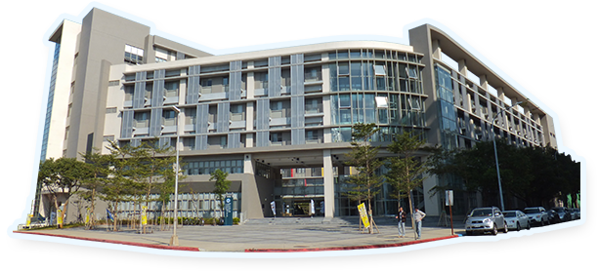

Accommodation
THE HO HOTEL (Hotel/HSR Free Shuttle Service)
THE HO HOTEL is the official accommodation for the 2025 Taiwan THz Summer Workshop, offering special reduced rates and essential assistance with your reservation. To book a room, please contact the conference secretary, Shelly Lee, at taiwanthz@gmail.com, before May 30.
Address: No.16, Daxue Rd., East Dist., Hsinchu City 300, Taiwan
Tel: +886-3-571-5888 Email: fo@thehohotel.com.tw
Google map location: https://maps.app.goo.gl/owuETkkwNpegJh458

和選旅
地址300新竹市大學路16號
電話03-5715888 信箱fo@thehohotel.com.tw

Transportation Guide
Travel between the Hotel and Conference Venue (12 minutes walk)
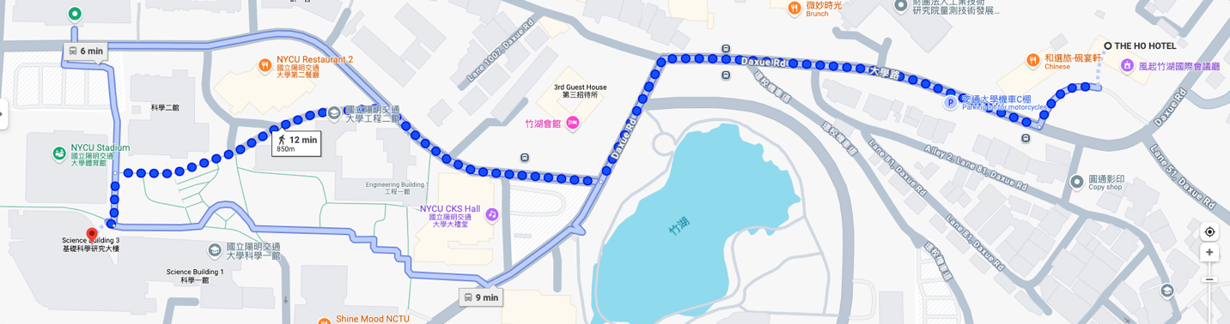

From Taoyuan Airport to THE HO HOTEL

Method 1: Taxi (direct)
to the THE HO HOTEL (和選旅)
Duration: 40–60 minutes (depending on traffic).
Cost: NT$1,200–1,500.

Method 2: Bus + Walk (9 mins)
1. Take the Bus (#1250, RI HAO BUS) from the Taoyuan International Airport Terminal 1/Terminal 2 Stop to National Yang Ming Chiao Tung Stop. Duration: 50 - 70 minutes. Cost: NT$200.
2. National Yang Ming Chiao Tung Stop, walk toward Daxue Rd for 3-4 mins and take the right turn. Walk for 4-6 mins to the THE HO HOTEL (和選旅).
Total Duration: 60 – 80 minites
Total Cost: NT$200.

Method 3: Airport MRT + High-speed rail (HSR) + Free Shuttle
1. Take the Taoyuan Airport MRT (Blue Line) from the airport to Taoyuan HSR Station (A18). Duration: 17-20 minutes. Cost: NT$25.
2. At Taoyuan HSR Station, take a high-speed rail (HSR) from Taoyuan Station to Hsinchu Station. Duration: 10 minutes. Cost: NT$130.
3. Take free shuttle* from Hsinchu HSR station directly to the THE HO HOTEL (和選旅). Duration: 10 minutes. *Reserve in advance.
Total Duration: 60 - 70 minites
Total Cost: NT$155.

Agenda
(TBD)
June 25 (Wed), 2025
16:00 – 17:00 Registration (Location: THE HO HOTEL)

June 26 (Thu), 2025
8:00 – 8:50 Registration (Location: SC001 (B1), NYCU Science Building III)
8:50 – 9:00 Opening Ceremony
9:00 – 9:50 Plenary Talk
9:50 – 12:00 Session A
9:50 – 10:20 Talk 1
10:20 – 10:40 Coffee Break
10:40 – 11:10 Talk 2
11:10 – 11:40 Talk 3
11:40 – 12:10 Talk 4
12:10 – 13:30 Lunch
13:30 – 14:30 Poster Session
14:30 – 17:50 Session B
14:30 – 15:00 Talk 5
15:00 – 15:30 Talk 6
15:30 – 16:00 Talk 7
16:00 – 16:20 Coffee Break
16:20 – 16:50 Talk 8
16:50 – 17:20 Talk 9
17:20 – 17:50 Talk 10
17:50 – 18:30 Transportation
18:30 – 20:30 Dinner

June 27 (Fri), 2025
8:00 – 9:00 Registration (Location: SC001 (B1), NYCU Science Building III)
9:00 – 9:50 Plenary Talk
9:50 – 12:00 Session C
9:50 – 10:20 Talk 11
10:20 – 10:40 Coffee Break
10:40 – 11:10 Talk 12
11:10 – 11:40 Talk 13
11:40 – 12:10 Talk 14
12:10 – 13:00 Lunch
13:00 – 13:30 Poster Session
13:30 – 15:30 Session D
13:30 – 14:00 Talk 15
14:00 – 14:30 Talk 16
14:30 – 15:00 Talk 17
15:00 – 15:30 Talk 18
15:30 – 15:40 Closing Ceremony
15:40 – 21:00 Excursion

June 28 (Sat), 2025
8:00 – 17:00 Excursion

Call for abstract
Call for Abstracts
Submission deadline: May 30, 2025.
Please use the provided Microsoft Word template, which can be downloaded HERE, to prepare your abstract. Please submit your one-page word and PDF files to HERE.

If you encounter difficulties with abstract submission, please contact the conference secretary at taiwanthz@gmail.com

Presentation
Presentation Guidelines
Oral Presentation
Please arrive at the session meeting rooms 15 minutes earlier and reconfirm your presentation slides with workshop staffs. Workshop staffs will stay in session meeting rooms to provide relevant assistance accordingly. All presentations should be presented in English.
- In every presentation, we will hold up a sign remind you that you have one more minute to enter the Q&A session. Once the Q&A session ends (5 mins later), we will remind you that time is up.
- The presenter must load the presentation file onto the session room computer before the beginning of the session. In general, it is NOT suggested to connect your own computer to the projector in the session room.
Poster Presentation
Presenters should arrive 15 minutes earlier to set up their posters.
The poster size is A0 format (Width 84.1cm x Height 118.9cm).
Presenters must be around their bulletin boards to make their presentations and answer questions during the poster sessions. Presenters who wish to keep their posters should remove them after the presentation. Any remaining posters will be removed by workshop staffs when the session ends.

Excursion
This two-day journey begins at the Shihmen Reservoir in Taoyuan, where we’ll enjoy a delicious multi-course feast featuring fresh fish by the water’s edge. As night falls, the colorful lights reflecting on the reservoir create a stunning evening view. Later in the evening, we’ll head up into the mountains to spend the night at a cozy farmhouse guesthouse nestled in the serene landscape of Lala mountain. The next morning, we’ll take a peaceful stroll along the forest trails of Lalashan Giant Trees park, soaking in the morning light, the lush greenery, and the refreshing phytoncides of the forest air. In the afternoon, we’ll visit Balung and Jiaobanshan Residence to admire the dramatic cliffside views of the Northern Cross-Island Highway and enjoy breathtaking panoramas of the reservoir from above. On our way back, we’ll stop by Cihu Mausoleum—a site rich in history—to reflect on a century of war, political shifts, and historical change. We’ll wrap up our journey at Daxi Old Street, where beautifully preserved buildings from the Japanese colonial period line the streets. Here, we’ll also indulge in local Taiwanese delicacies such as sticky rice sausage, savory rice pudding, tofu pudding, and marinated dried tofu—a perfect ending to a memorable trip.

這趟兩天一夜的旅程，將從桃園石門水庫展開。在水庫畔享用多樣新鮮的活魚料理，同時欣賞堤岸邊絢麗迷人的五彩夜景，為旅程揭開美好序幕。夜晚，我們將前往位於拉拉山的農場民宿，沉浸在山林間的靜謐夜色中。翌日清晨，可漫步於拉拉山國家森林遊樂區的步道，在晨光、森林與滿滿芬多精的環繞下，感受大自然的洗禮。午後，我們將造訪巴陵及角板山公園，欣賞壯麗的北橫斷崖風光，遠眺壯闊的水庫景色，感受山水交融的震撼。返程途中，特別安排前往慈湖陵寢，一窺歷史現場，緬懷百年來的戰爭歲月與政治更迭。最後一站，我們來到富有歷史風情的大溪老街，欣賞保存完整的日治時期街屋建築，並品嚐在地美食──糯米腸、碗粿、豆花與香氣四溢的豆干滷味，為這段充實旅程畫下圓滿句點。

Date:
June 27 (Fri) & June 28 (Sat), 2025
Price:
200 USD (International) / 6000 NTD (Domestic). Accompanying person: 150 USD (International) / 4500 NTD (Domestic)
Excursion flyer:
Download

Registration
Registration is now open. Register before May 15th to receive a discount.
Click HERE to register.

Regular registration fees include lunch, refreshment and banquet. Student registration fees include lunch and refreshment.

International Registration Fee
Early-bird (by May 15, 2025): Regular: 250 USD /Student: 70 USD
Late (from May 16, 2025) / Onsite: Regular: 350 USD / Student: 90 USD
Domestic Registration Fee
Early-bird (by May 15, 2025): Regular: 8000 NTD / Student: 2000 NTD
Late (from May 16, 2025) / Onsite: Regular: 11000 NTD / Student: 2500 NTD
Additional banquet ticket for accompanying person: 40 USD (International) / 1200 NTD (Domestic)

In case of cancellation, a written notification should be sent directly to the conference secretary (Shelly Lee, email: taiwanthz@gmail.com).
Before June 6, 2025: 100% of the registration fee will be refund after deducting a handling fee. On or After June 6, 2025: the registration fee and banquet fee will not be refunded (No refund).

